Enterprise IT User Guide: SA1-2431 Newsroom C088 Flexible Full-Bleed Card Carousel Loop

Prepared for:
Emerson Use
Prepared by:
Fernan Fajardo
Enterprise IT Digital Engagement Team

Revision and Signoff Sheet
Change Record
Date | Author | Version | Change reference
02/05/2021 | Fernan Fajardo | 1.0 | Initial Creation

Contents
Revision and Signoff Sheet 2
Overview 4
Pre-Requisites 4
Layout Variant Creation 4
User Steps 5
Query List Creation 5
Local Settings Creation 8

Overview

Newsroom C088 Flexible Full-Bleed Card Carousel Loop is a new component that features content in a responsive carousel layout configured based on news type and designated content tags.

Pre-Requisites

Layout Variant Creation

- Go to All Content > Settings > Options > Viewtypes > CMQueryList

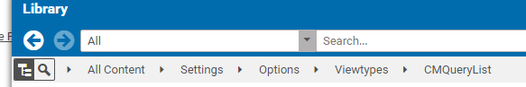

- Create/Add new Layout Variant

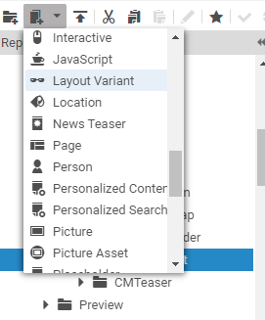

- Name it C088 – Flexible Full-Bleed Card Carousel Loop
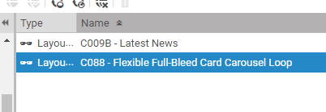

- Open the Layout Variant and add the following details

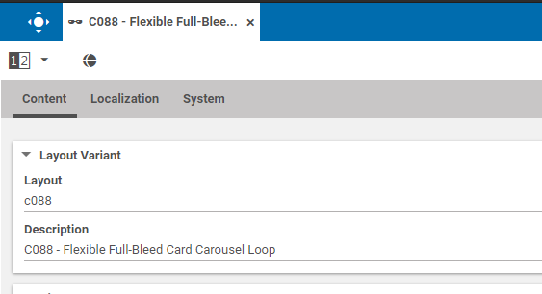

- Click Finish Editing and Apply all changes

User Steps

Query List Creation

- Go to a folder which the query list will be created
- Click create Query List
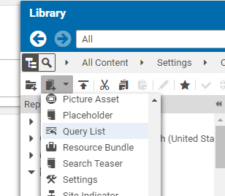

- On the Query List, Update the content tab as needed

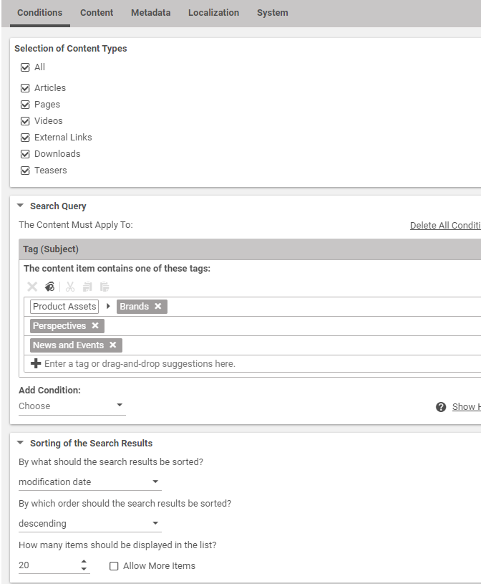

- On the content tab, Add Teaser Title. This will server as the header of the carousel
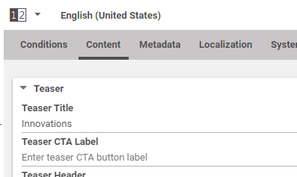

- On the content tab, change the layout variant to C088

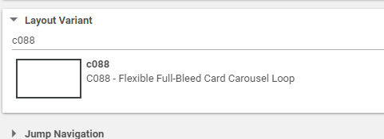

- Click Finish Editing and Apply all changes

Local Settings Creation

Adding a CTA on the carousel

- Go to the system tab of the query list created
- Add a struct list and name it newsroom.carousel.cta
- Add a struct on the struct list
- Inside the struct add a string and name the key as title and value Automations Solutions (value depends on what is required)
- On the same struct add a link and name the key as url and add/drag a page for the link
- Repeat the steps 3-6 as needed.
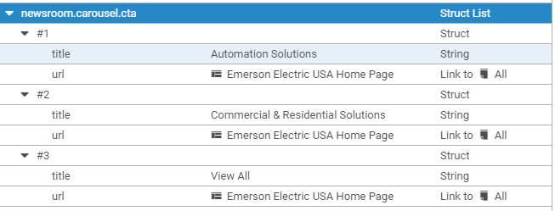

Adding the labels on the cards

- Add a struct list and name it newsroom.labels
- Add a struct on the struct list
- Inside the struct add a Link list and name the key as topicLabel and add/drag a tag (Topics)
- Add a new struct on the struct list
- Inside the struct add a Link list and name the key as subjectLabel and add/drag a tag (Brands,Perspective,People, etc.)
- Add a new struct on the struct list
- Inside the struct add a Boolean and name the key as enableDate. Click the checkbox for the label 3 to display and uncheck the checkbox to hide it
- Click Finish Editing and Apply all changes

