Technical Document – C087 Trending News Component

Table of Contents
Business Requirement Specification 3
Functional specification 3
Technical specification 4
Creation of contents in studio 4

Business Requirement Specification
A new component is required to be created wherein the content authors should have the ability to highlight new and evergreen content pieces of news in a hierarchical orientation placed within a six-grid structure.
The expected use case:
- C087 is expected to display six most recent items in a grid based on the results returned from each business platforms set in individual query lists using respective tags.
- The contents being displayed in the grid is entirely dependent on the six placement tags set in the local settings of the C087 collection.
- Based on the order in which the placement tags are arranged in the local settings, the six grids will be populated in the component.
The content authors can arrange these news items in any probability within the six-grid placement structure of the C087 component.
C087 is expected to be driven using the tag logic and should be flexible enough to accommodate for any other use cases like:
- The content editors can have all the six grids display the latest news from a specific business platform like Automation solution by setting the automation solution tag in all the six grid placement lists in the C087 local settings.
- Content editors can also associate other content types to the C087 component.

Functional specification
- A new collection component for the C087 was created in studio which will accept query lists as the items for receiving the latest news contents based on the business platform tags set specifically in the mentioned query lists.
- The contents being displayed in the grid is entirely dependent on the six placement tags set in the local settings of the C087 collection and the content authors can associate any business platform to the mentioned grid placement list.
- By default –
  - Autosol news are associated with Grid areas 1 and 4.
  - Comres news are associated with Grid areas 2 and 5.
  - Corporate news is associated with Grid areas 3 and 6.
- The grid areas 1, 2 and 3 will only display the images.
- Placements 1 - 6 are ranked in priority order with 1 being most recent content and 6 being least recent.
- If multiple content items have the exact same date, display whichever is picked up first by the system.
- On hover, the title text should change color from Rich Black (#2D383F) to the brand’s primary CTA color (i.e., Emerson Green #00AA7E).
- The entire content area should be clickable for each item in the grid.
- On click sends the user to the corresponding news content detail/article page.

Technical specification

Creation of contents in studio
C087 Trending News Collection:
- Create a new collection in studio. Add the teaser title for the component. By default, it is “Trending News”.
- Add the “C087 - Trending News Grids” Layout variant to the above collection. Please refer to the image below.
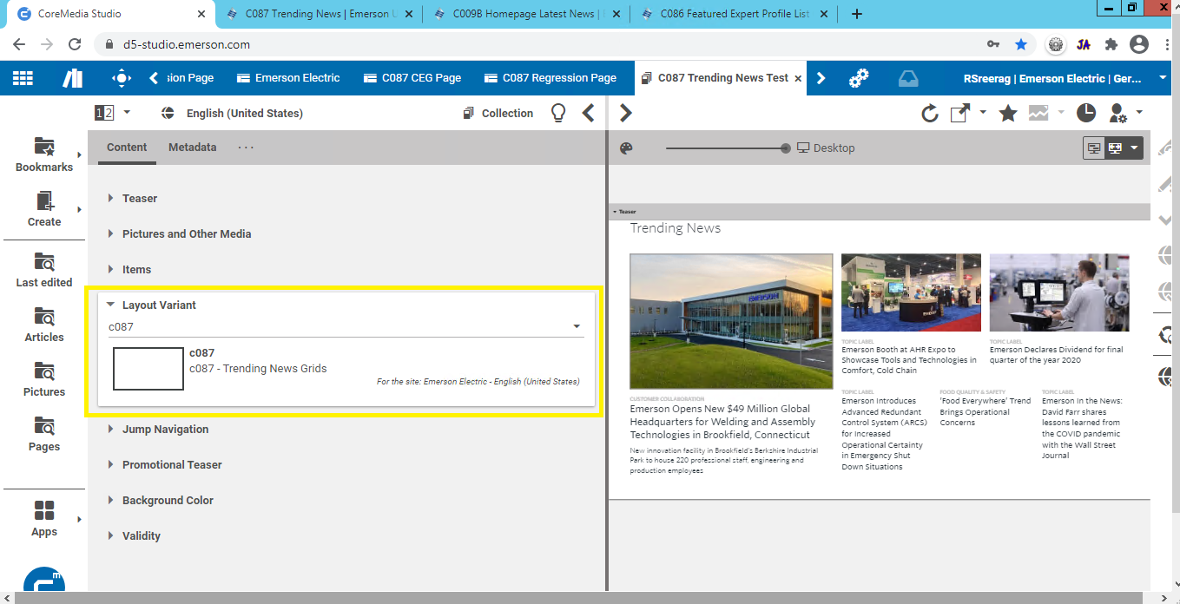
- Add the required query lists with respective tags associated for each platform to the C087 collection as shown in the image below.
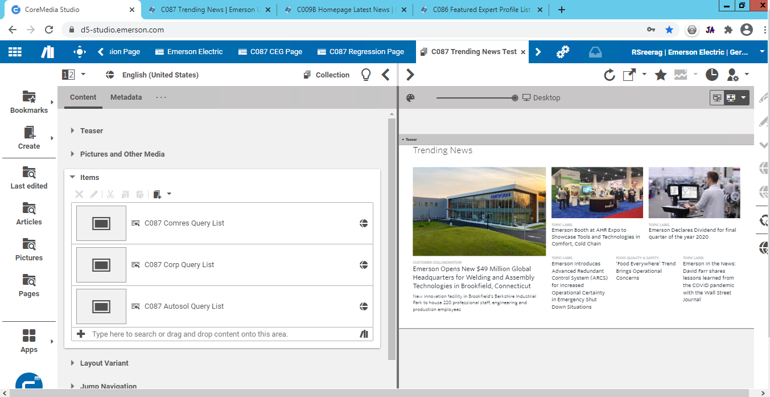
- Create a link list with the name “gridPlacemetTags” in the local settings.
- The six placement tags can be associated with this link list.
- The name of the tag is important as the underlying code identifies the link list through this string value. Please refer to the image below.
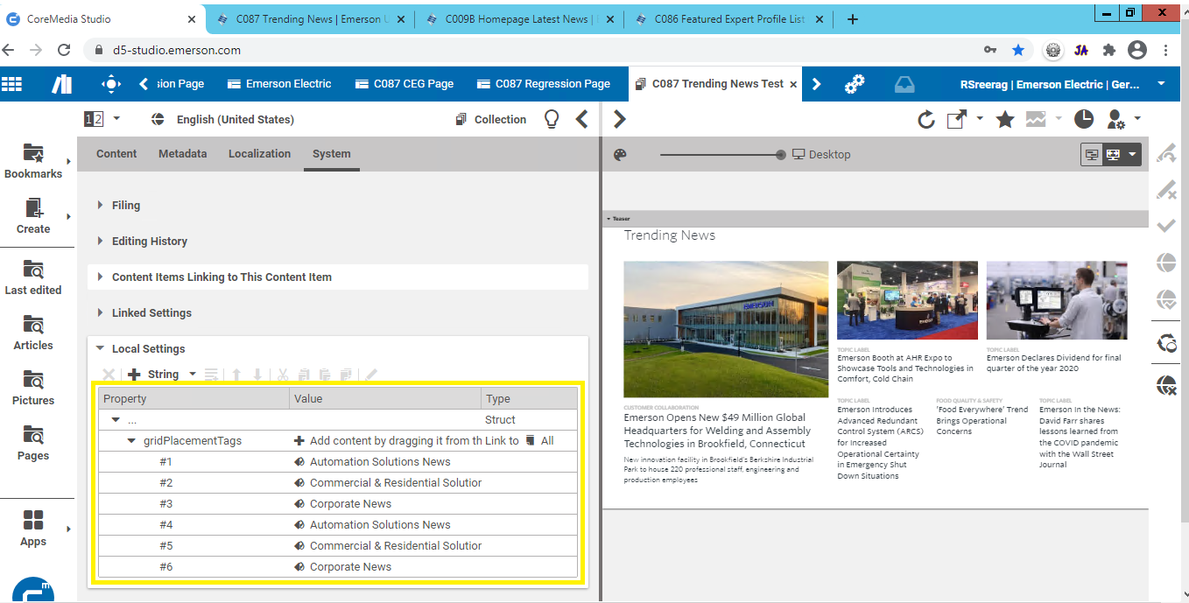

Business Platform Specific Query List:
- Create the Query List component in studio. By default, in the d5 and s5 environment, three platform specific Query Lists are created currently: Comres, Autosol and Corporate.
- In the conditions tab of the query list:
  - The "Pages" content type needs to be selected from the available check list of content types.
  - Under the Search Query section, "Tag(Subject)" needs to be selected.
  - The required business platform tag needs to be added under this section. Please refer to the image below:
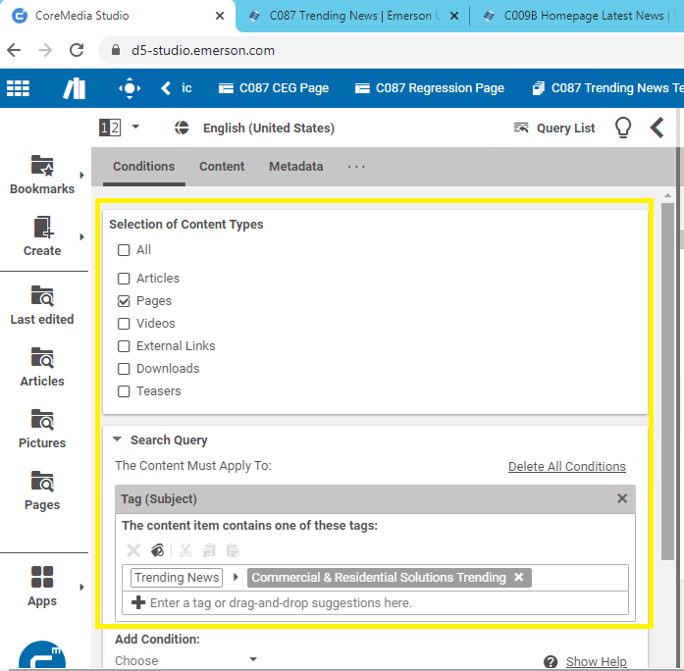
  - Any business platform tags can be associated here but the only requirement is that the tag needs to be present in the metadata of the incoming contents created during content authoring.
  - Sorting section should include - external display date in descending order with a maximum of six item list to be returned.
  - Allow more items checkbox is optional. Please refer to the image below:
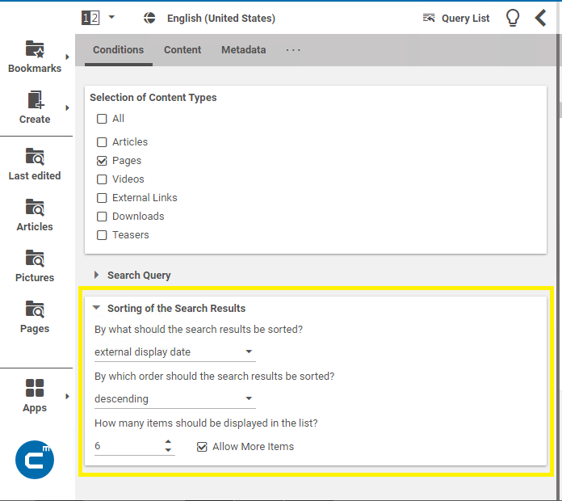
- In the content section:
  - The teaser title is optional.
  - All other sections can be ignored.

Grid Placement link list for the placement tags in the Local Settings of C087 Collection:
- In the local settings of the C087 Collection, create a link list and name it - “gridPlacemetTags”.
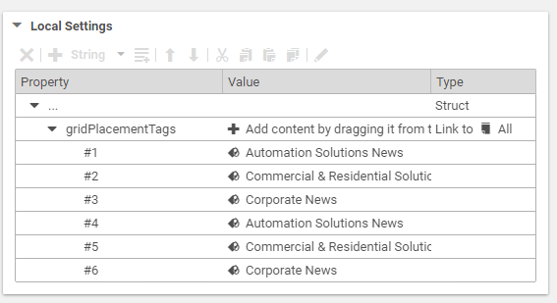
- Above Name convention for the tag is important as the underlying code identifies the link list through this string value.
- The list should always contain six tags.
- The tags can be arranged in any probability by the content editors.
- The important requirement of the tag is that the same tag needs to be present in the metadata of the incoming contents created during content authoring.
- Any business platform tags can be used. This tag can be like the ones being used in the Query Lists mentioned above.

Building the Topic Label for the items in search configuration using the Topic Tag:
Note: As a future enhancement, this configuration in the studio needs be changed and made more flexible so that it can be driven from the local settings of C087 as well.
- Create a link setting in the SearchConfiguration settings file. The string name should be given as – “trendingnews.topic.tag”. Naming convention is important.
- Add the necessary parent tag to the above link. The backend code uses this tag to search for the Topic Label from the incoming contents and populate the same respectively in the Grid items.
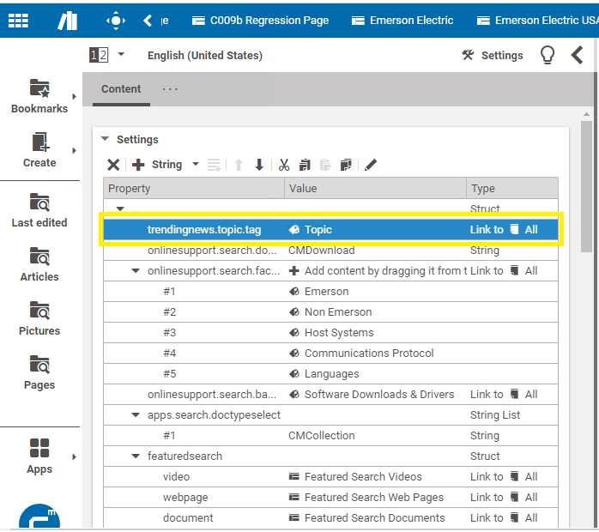
- The related code changes are available in the EmersonFreemarkerFacade.java:
